SRINIVAS UNIVERSITY

Mangalore-575001, Karnataka (India)

RESEARCH CENTRE FOR PAYMENT BANKING

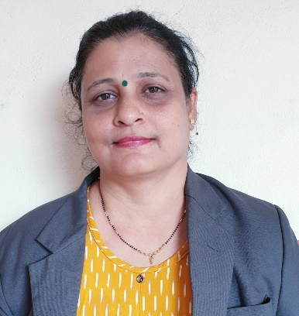
G. NANDINI. PRABHU

Payment banks is an Indian new model of banks conceptualised by the Reserve Bank of India. These banks can accept a restricted deposit, which is currently limited to Rs 100,000 per customer and may be increased further. These banks can not issue loans and credit cards. The centre for research in social accounting is founded in 24 November2014 by the Reserve Bank of India.
Objectives
1.To analyse the methods of payment banking.
2.To know payment banking guidelines used by banks.
3.To understand the way Indian banks, build payment banking.
4.To recognize the problems involved in introducing payment banking in the country.
5, To Identify the required steps needed to properly execute payment banking all over India.
Working papers:
- A study on Sustainable payment banks followed by 50 banks
- A case study on Sustainability report of Canara bank
- Awareness and Impact of payment banks initiatives on investors decisions
- Importance of payment banking practice.

Members;
- Bhuvana .R
- Krithi
- D’souza Prima.Frederick
- Priyanka Nayak
- Sujaya. H
- Meghana.

Coordinator’s details;

Mrs. G, Nandini Prabhu
W/O G. Avinash. Prabhu
Research Scholar,
School Of Management and Commerce,
Srinivas University,
City Campus, Pandeshwar
Mangalore – 575001

Email id:
nandiniprabhu.cmc@srinivasuniversity.edu.in

